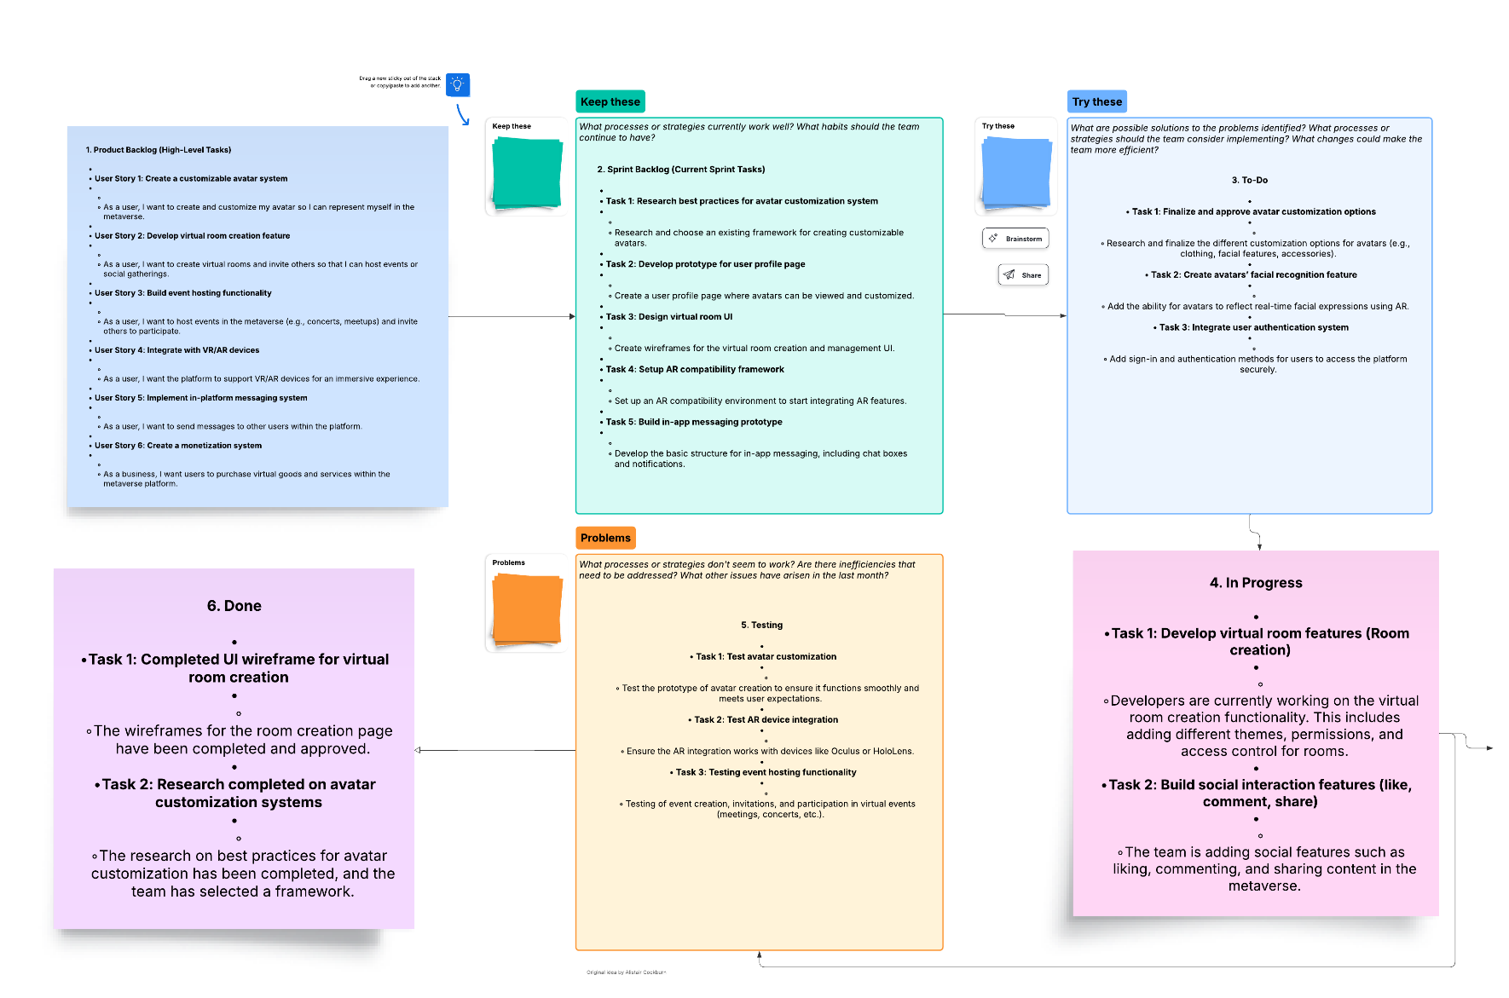 **B.Tech(ECE)-QUANTUM UNIVERSITY-1-Task1-** **Agile Development Models**